***HR SCORECARD MEASURING SUCCESS IN TALENT MANAGEMENT***

***INTRODUCTION:***

The Tableau HR Scorecard: Measuring Success in Talent Management The Tableau HR Scorecard is a framework designed to measure and evaluate the success of talent management strategies within an organization. It provides a way for HR professionals and business leaders to track and analyze key performance indicators (KPIs) related to workforce planning, recruitment, retention, and development. The HR Scorecard consists of four main perspectives:

1. Financial Perspective: This perspective focuses on the financial impact of HR initiatives, such as the cost of recruitment, training and development, compensation and benefits, and turnover.

2. Customer Perspective: This perspective measures the satisfaction of internal and external customers of HR services, including employees, managers, and job candidates. It includes KPIs such as employee engagement, manager satisfaction with HR support, and candidate experience.

3. Internal Process Perspective: This perspective assesses the effectiveness and efficiency of HR processes, such as recruiting, on boarding, performance management, and employee development. It includes KPIs such as time to fill vacancies, time to productivity for new hires, and training hours per employee.

4. Learning and Growth Perspective: This perspective evaluates the organization's investment in and its ability to innovate and adapt to changing business needs.

***OVERVEIW:***

An HR scorecard for measuring success in talent management is a strategic tool that helps HR Professionals assess and communicate the effectiveness of their talent management practices. Here’s an overview of key component typically included in such a scorecard.

***PURPOSE:***

The purpose of HR talent management is to identify, attract, develop, and retain talented individuals within an organization to ensure it has the right people in the right position to achieve its strategic goals .

***EMAPTHY MAP***

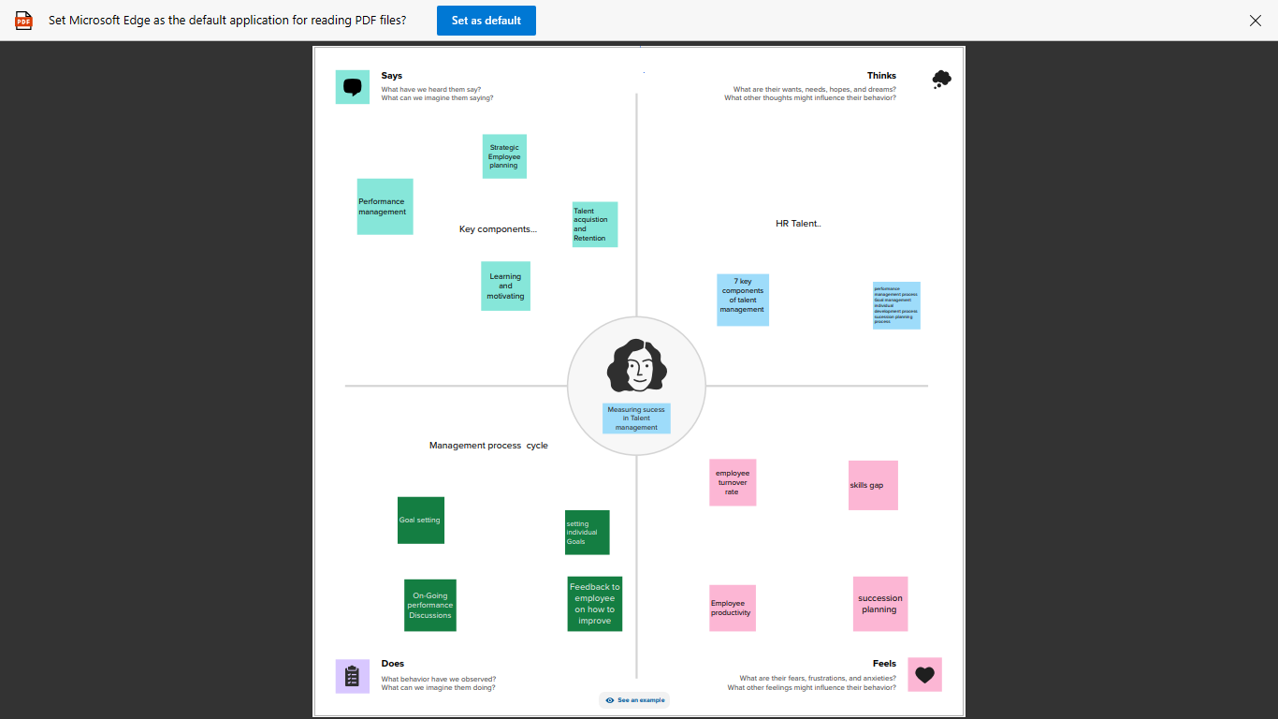

# *BRAIN STROMING*

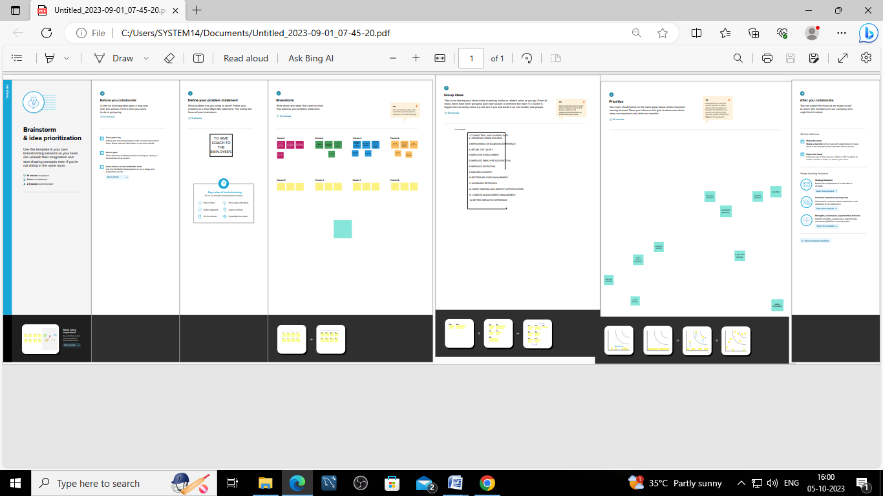

## *DASHBOARD*

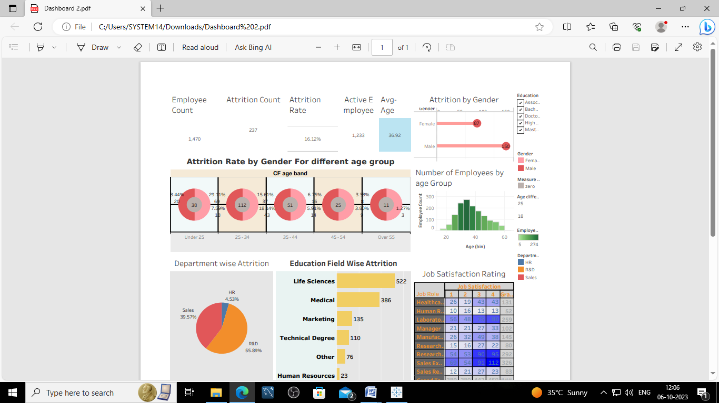

# *Department Wise ATTRITION*

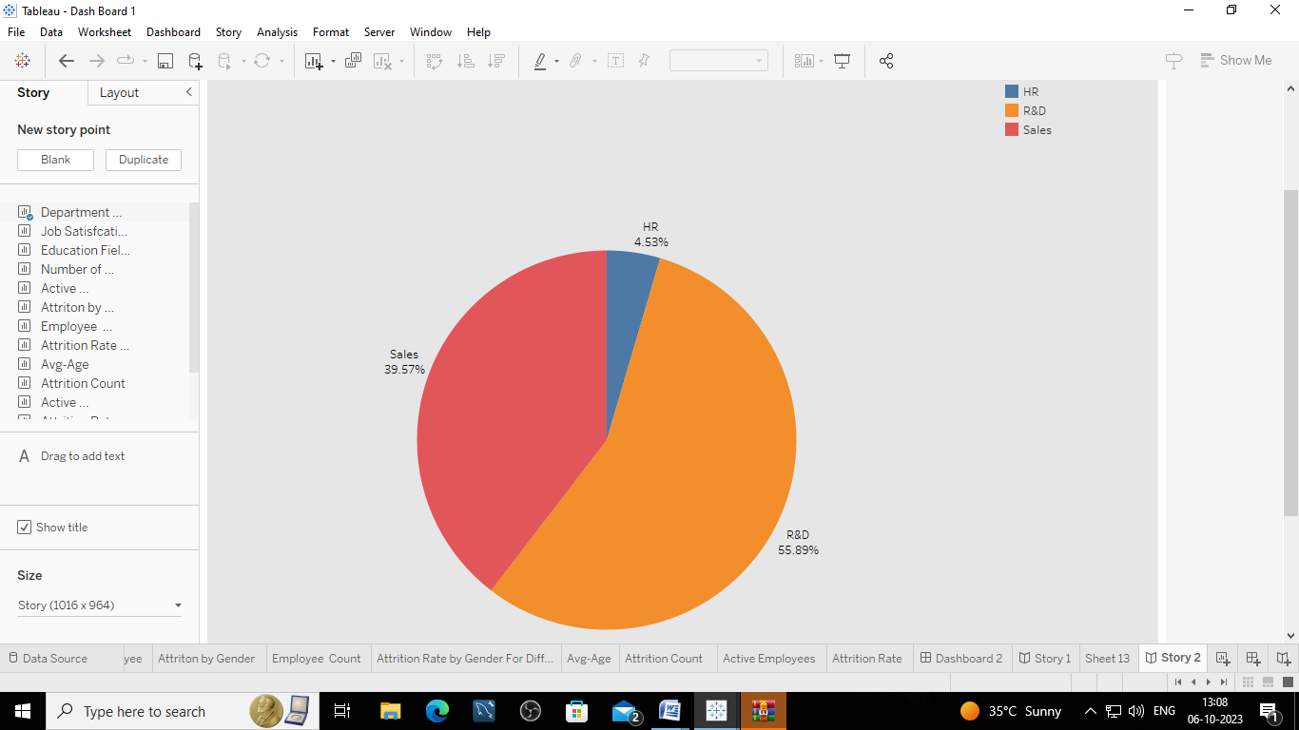

***Education field Wise Attrition***

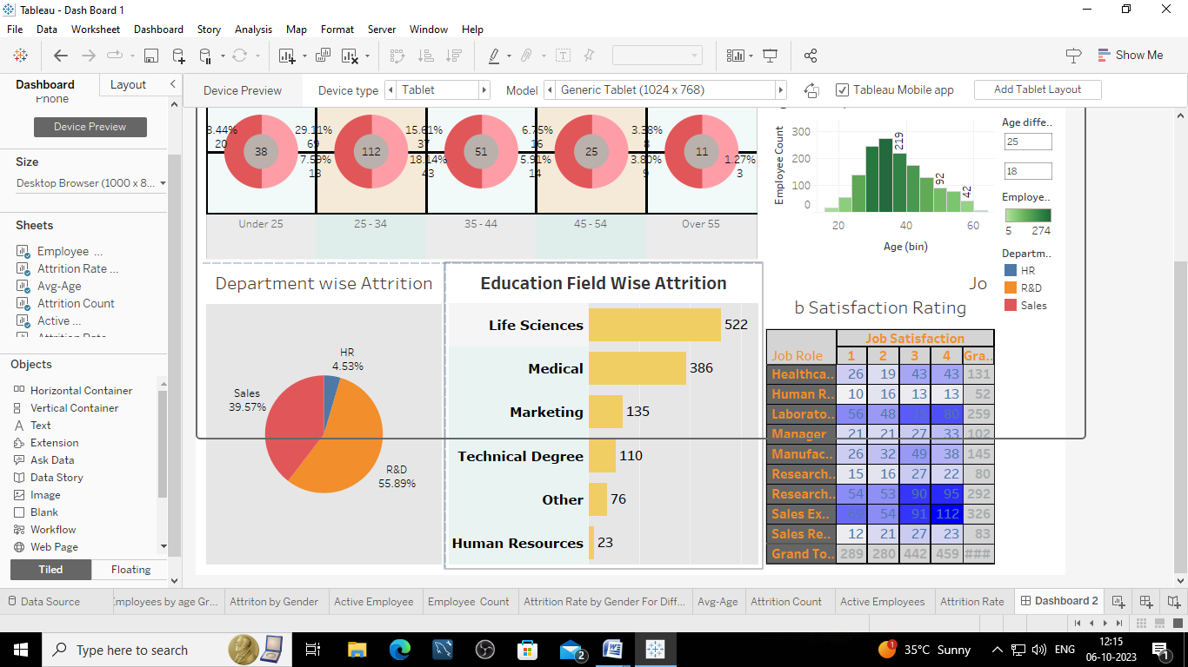

***JOB SATISIFICATION***



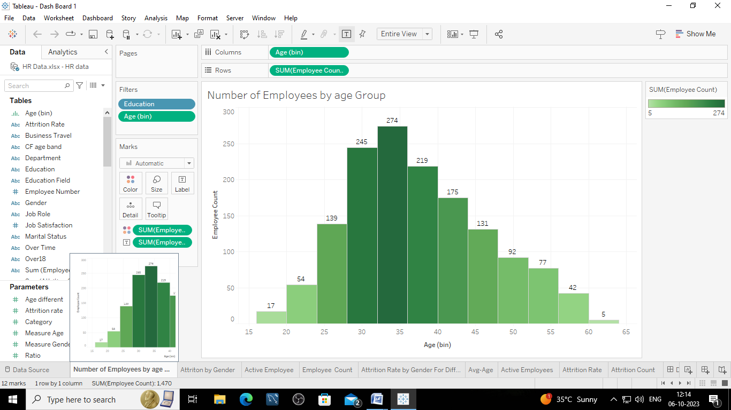

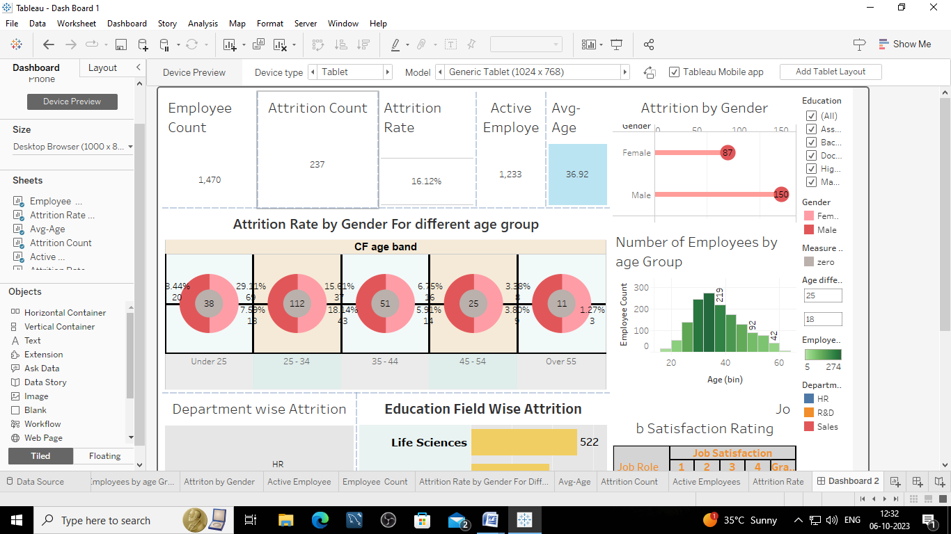

#### Attrition rate by Gender For Different Age Group

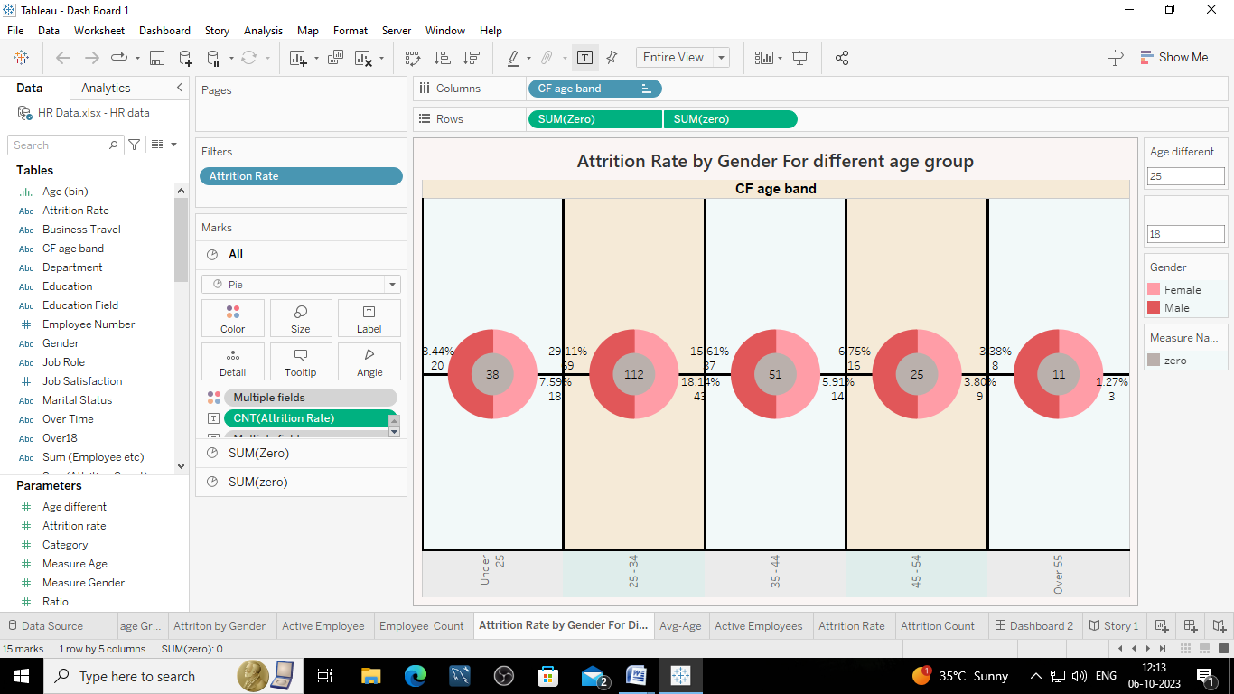

# *Attrition by Gender*

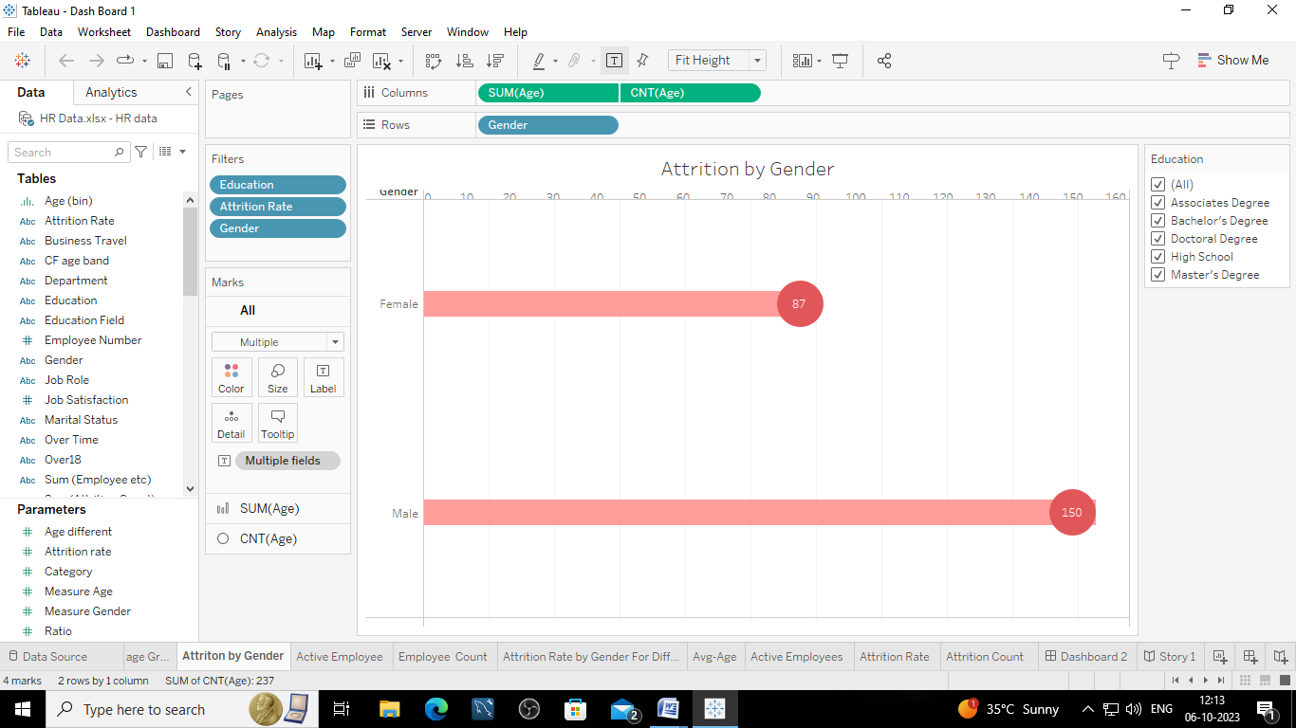

***STORY***

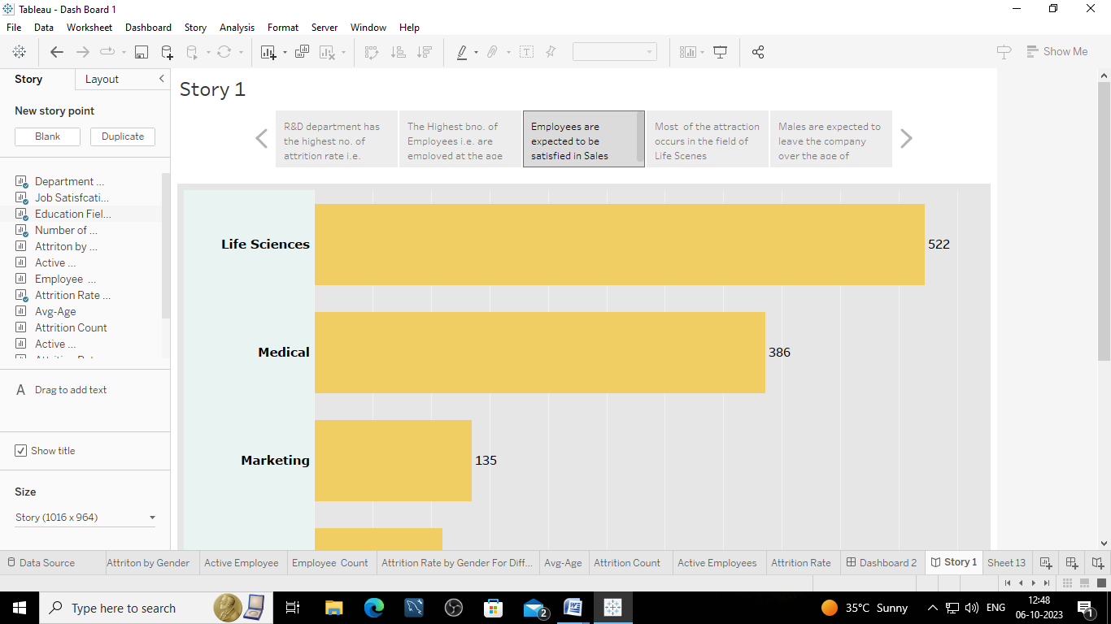

## *STORY*

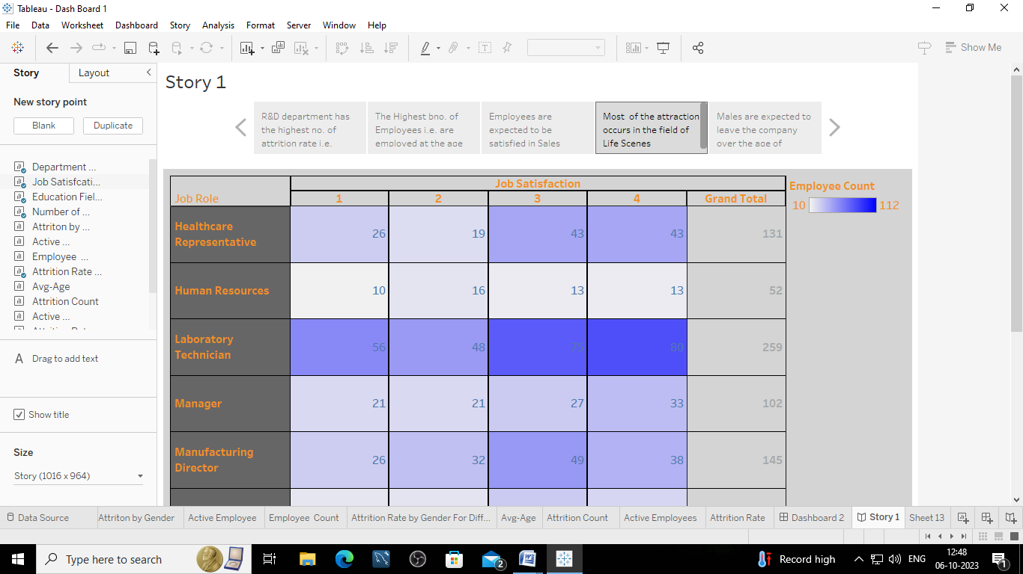

# *STORY*

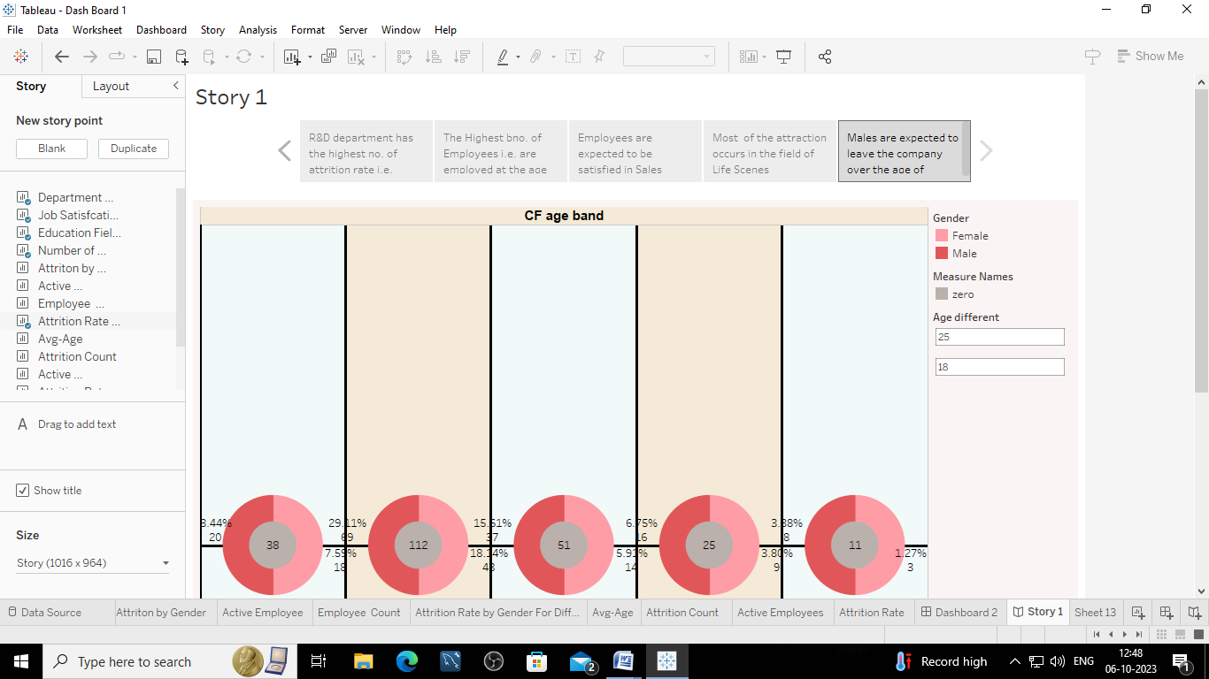





***ADVANTAGE :***

The Scorecard ensures that talent management strategies are aligned with the overall business objectives , helping HR teams focus on hiring and developing the right talent to drive the company’s success.

It provides a framework for collecting and analyzing data related to talent acquisition, retention, and development. This data-driven approach allows HR to make informed decisions and adjustments to their talent strategies.

The HR Scorecard enables the tracking of key performance indictors related to talent management, such as turnover rates, employee engagement, and skill development. This helps improvement and success.

The HR Scorecard offers a structured approach to talent management that contributes to organizational success by aligning HR strategies with business Goals, promoting data during decision-making and fostering continuous improvement.

It helps align HR strategies and initiatives with the overall business objectives, ensuring that talent management efforts directly support the company’s mission and vision.

***DISADVANTAGE***:

Developing and maintaining an HR Scorecard can be a complex and resource intensive process. Gathering relevant data ,defining key performance indicators and establishing metrics can be time consuming and require specialized expertise.

Implementing an HR Scorecard may face resistance from employees who are not accustomed to such a data-driven approach. Cultural resistance to change can hinder the successful adoption of the Scorecard.

There is risk of focusing too much on the metrics themselves rather than the underlying talent management goals. Overemphasis on meeting specific metrics can sometimes lead to unintended consequences, such as “gaming” the system to achieve desired numbers.

Developing and maintaining an HR Scorecard system can be costly, especially for smaller organizations with limited resources. The costs associated with data collection, analysis tools, and training should be considered.

In some cases, organizations may become overly focused on meeting specific metrics outlined in the scorecard, potentially leading to a “box-ticking” mentality where the quality of talent management is sacrificed for the sake of achieving numerical targets.

***OVERVIEW:***

HR scorecards emerge out of the "balanced scorecard" theory founded by management consultant originated the balanced scorecard out of a work assignment to connect the dots between his employer's quality improvement and strategic goals. The end goal for an HR scorecard is to establish a linkage between HR and organizational goals in support of strengthening the employer-employee relationship, creating a productive work environment and improving the bottom line. For example, one of the categories that HR scorecards measure is employee turnover. Through measuring turnover, an HR scorecard evaluates how turnover impacts the company's profits, how much it costs to replace employees, the effect turnover has on remaining employees' morale and, thus, the organization's strategic goal to foster a productive work environment.

***Intangibles:***

One of the disadvantages of the HR scorecard is that measuring intangibles is difficult, if not impossible, without imparting a degree of subjectivity on the part of HR staff. Subjectivity undermines the validity of data and, therefore, limits the credibility of HR and its ability to prove its worth to an organization. The very things HR is charged with and the organization believes HR can do well are the most difficult to measure, such as related to employee concerns.

***Accuracy:***

Employees have been known to fudge on exit interviews and workplace surveys, which results in inaccurate HR scorecards that propose measurements of employee sentiment. Employees may not intentionally attempt to skew survey results; however, they may provide distorted answers to questions about their employment experiences to appease HR staff or their supervisors and managers. They might pretend they are perfectly happy with the workplace when they are actually dissatisfied with certain aspects of the employment experience. The clear disadvantage of HR scorecards is that they cannot be 100 percent accurate.

***Action:***

The term "HR scorecard" can be a misnomer because it suggests that measurement is the only expectation. Another disadvantage to HR scorecards is that their usefulness can be limited by both HR staff and the company's leadership. Ideally, an HR scorecard doesn't just contain metrics related to HR functionality and the linkages between HR, the workforce and the organization's business goals. The extended purpose of an HR scorecard is to develop action plans for the HR department and the company's leadership team. For example, instead of simply measuring the impact of turnover on the organization's workforce goals, use HR scorecard metrics in drafting an action plan for turnover reduction.

*Interpretation:*

HR practitioners who fully understand the implications of workplace metrics should interpret HR scorecard results. If metrics contained in an HR scorecard are produced or synthesized by an outside consultant, it can result in complex or even inaccurate interpretations. HR scorecards are more effective and more useful when they're produced in-house by HR staff who are familiar with the organization's goals from an insider's point of view.

***Conclusion:***

The Tableau HR Scorecard is a framework designed to measure and evaluate the success of talent management strategies within an organization. It provides a way for HR professionals and business leaders to track and analyze key performance indicators (KPIs) related to workforce planning, recruitment, retention, and development. A scorecard will have some targets. A dashboard is a monitoring tool that shows how a company is performing relative to a KPI/metric at any given time.